

Automated Support Infrastructure Remote ASI Client Update User Guide

Table of Contents

Introduction 3
Setting up a remote ASI client update 3
Uploading the ASI client installation executable 3
Adding a version record 3
Navigation note 3
Adding a version record by copying an existing one 8
Assigning a version to one or more sites 9
Assigning one version to multiple sites in one step 10
Note on version assignment removal 11
A note about version number comparison and forced updates 12
Scheduled execution of remote ASI client update 12
On-demand remote ASI client update execution 13
Checking the status of ASI client update process 18

Introduction
The Updates module on the ASI server lets you update the ASI client at remote sites without having to be on site. The entire process takes no more than a couple of minutes whether it’s for one, some, or all sites.
This document is a step-by-step guide for remotely upgrading the ASI client at your site(s). For additional information about the Updates module on the ASI server, please refer to Automated Support Infrastructure Site Management User Guide.

Setting up a remote ASI client update
To carry out the ASI client remote update using the Updates module, you should perform the following steps:

Uploading the ASI client installation executable
- Download the new ASI client installation executable from the HandsFree Networks FTP or HTTP server when notified to do so.
- Copy the name of the ASI client installation executable downloaded, such as hfn-inst-2.001.0990.BM.exe into a plain text scratch file. This ASI client installation executable file name is critical when setting up the version information.
- Upload the ASI client installation executable to the /asiservername/main/pub/patches folder on your ASI server using the upload account on the ftp server installed on your ASI server following the instructions provided in the document named HFN asi server file upload instructions xxxxxx.doc, where xxxxxx should be replaced with the name of your organization.

Adding a version record
- Log onto the ASI Updates module. Open a browser window and enter the following address https://asiservername/main/updates/index.php
Substitute asiservername with the URL of the ASI server your sites log to.
Once you are logged on, you will see the Set Site Version page (See figure below).

Navigation note
Clicking on the updates link under the Site Management heading on the Welcome page, or to the right of the sites: label at the upper right-hand corner on any page on the ASI event management facility, will take you to the Set Site Version page from anywhere in the ASI server.
Once you access the Updates module of the ASI site management facility, a second level navigation bar appears on the page:
- updates: versions | sites | machines
To get back to the Set Site Version page from anywhere within the Updates module, just click on the sites link on the second level navigation bar.
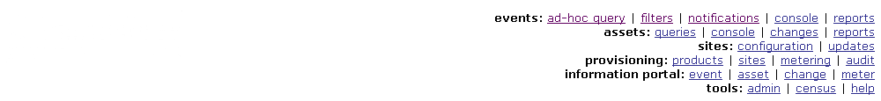
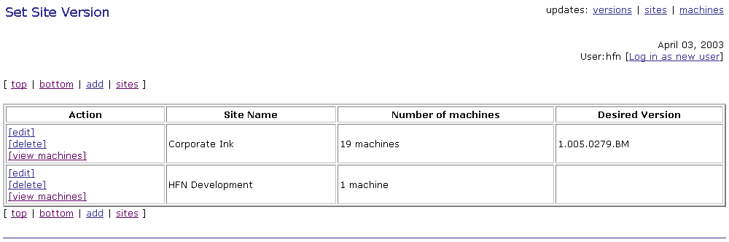

- Clicking on the versions link on the second level navigation bar, will take you to the Available Versions page (See figure below).
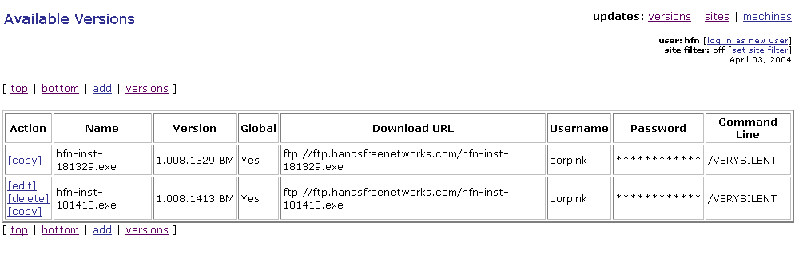
- Right-click on the add link at the bottom or top of the Available Versions page and choose Open in New Window. The Add a Version Record page (See figure below) will be displayed in a new window. Arrange the Available Versions page and the Add a Version Record page windows so you can get to both of them.
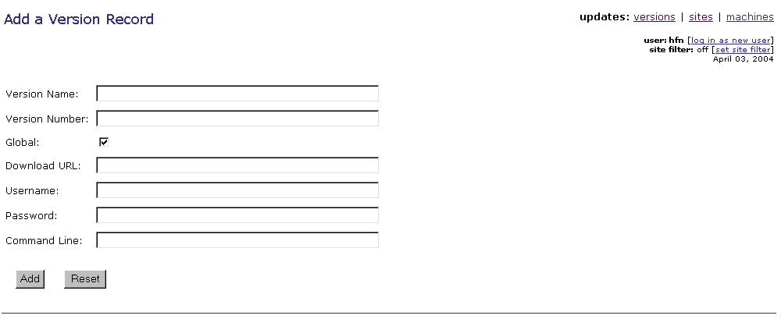

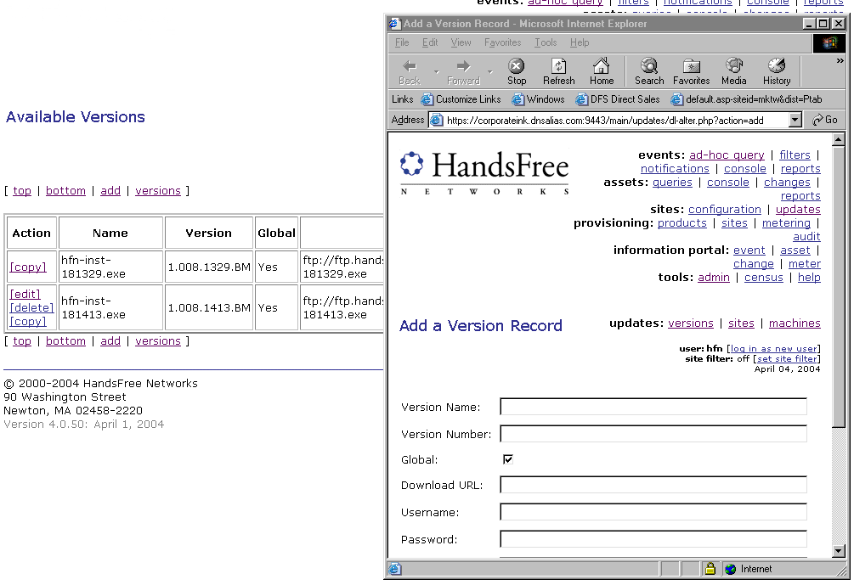
- Enter a name for the version record you are creating in the box to the right of the Version Name label. This will be the name the version record will be referred to.
- Enter the version number. ASI version numbers have x.yyy.zzzz.BM format. To extract the correct version number proceed as follows:
- copy the part of the file name starting with the first digit after "inst-" and ending with "BM" (including BM)
For example if the installation executable file name is hfn-inst-2.001.0990.BM.exe, the version number is 2.001.0990.BM
Enter this version number into the Version Number text box on the Add a Version Record page.
- If you want the version record you are creating to be available to other users on the ASI server, click on the box to the right of the Global label.
- Select the site you are applying the new version to from the Site Name drop down list. Always test the new version on your site first.
- In the Download URL box enter the following
- https://asiservername/main/pub/patches/asiclientinstallationexecutablefilename
For example:
- https://nanoheal.org/main/pub/patches/hfn-inst-2.001.0990.BM.exe
Please note that because asiservername\main\pub\patches can be accessed anonymously, you do not need to enter a user name or password on the Add a Version Record page.
If you place the ASI client installation executable on a server (FTP, or HTTP/HTTPS) that requires authentication, you should enter a valid user id and password in the fields labeled Username, and Password respectively.
- Enter the command line parameters that you want to use when running the ASI client installation executable in the box to the right of the label Command Line.
The ASI client installer has three command line switches:
a) /VERYSILENT
It makes the installation silent The only exception are the progress dialog boxes displayed when the ASI network driver is installed for the first time on Microsoft Windows NT4 systems during the "driver binding" step that occurs twice.
b) /ID=XXXXXXXXXX
It lets you enter the registration code for a site in the installer's command line eliminating the need for any user interaction. The letters in ID are not case sensitive. You can have iD, Id, id etc. There should not be any spaces in the string. There should only be a space that separates the name of the ASI client installation executable file from the command line argument.
For example:
hfn-inst-160665.exe /ID=XXXXXXXXXX
c) /NDS controlling the installation of the ASI network driver
/NDS=0
If present in the ASI client installation executable command line, the /NDS=0 switch will prevent the installation of the ASI network driver on systems where the ASI client is not yet installed, or where the ASI network driver was not previously installed. On systems where the ASI network driver is installed, using the /NDS=0 switch in the ASI client installation executable command line will result in the removal of the ASI network driver. The letters in NDS are not case sensitive.
PLEASE NOTE THAT REMOVING THE ASI NETWORK DRIVER WILL CAUSE THE NETWORK CONNECTIONS ON THE SYSTEM WHERE IT IS BEING REMOVED FROM TO BE RESET. THIS ACTION IS PERFORMED BY THE OPERATING SYSTEM INDEPENDENTLY OF ANY ACTION TAKEN BY THE ASI SOFTWARE.
/NDS=1
If present in the ASI client installation executable command line, the /NDS=1 switch will force the installation of the ASI network driver on systems where the ASI client is not yet installed, or where the ASI network driver was not previously installed. The letters in NDS are not case sensitive.
For example:
hfn-inst-173228.exe /NDS=0
If neither the /NDS=0 or /NDS=1 options are used, the ASI client installation executable will install the ASI network driver on systems where the ASI client was not previously installed, and on system where the ASI client is already installed it will leave the ASI client in its current state with regard to the ASI network driver.
The /VERYSILENT, /ID, and /NDS=0 command switches can be used in the same command line. When using any of the ASI client installer command line switches, there should not be any spaces in the command line switch string. There should only be a space separating the name of the ASI client installation executable file from the command line argument, and the command line switches from each other, if you are using more than one.
- Click on the  button. The Version Record Added page will be displayed (See figure below). Close it. After you refresh (press the F5 function key on your keyboard) the Available Versions page, the new version record for the site you selected will show up in the list. Of available versions.
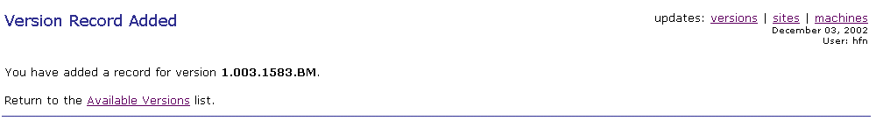

Adding a version record by copying an existing one
Alternatively, you could use one of the existing version records as template for a new version record by using the copy action. Note that only the copy action is possible with version records that are available for you to use, but which you did not create.
If you want to use the copy action to add a version record, you should perform the following steps:
- Click on the [copy] link to the left of the entry for the version record that you want to use as the template for the new one. The Copy a Version Record page will be displayed (See figure below).
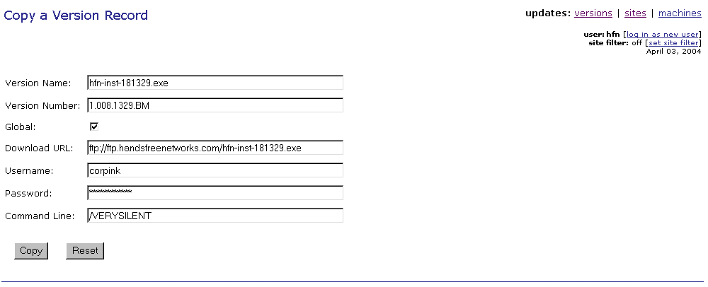
- The Copy a Version Record page is an exact copy of the Add a Version Record page. Perform steps 4) to 9) immediately above.
- Click on the  button. The Version Record Copied page will be displayed (See figure below). Close it. After you refresh (press the F5 function key on your keyboard) the Available Versions page, the new version record for the site you selected will show up in the list. Of available versions.
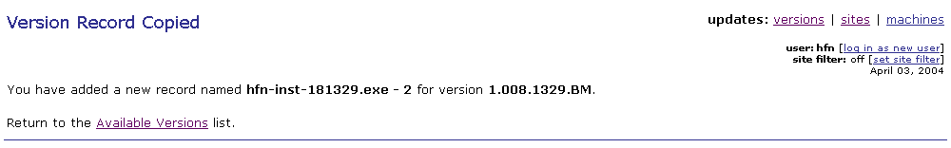

Assigning a version to one or more sites
- Click on the sites link on the second level navigation bar. The Set Site Version page will be displayed once again (See figure below).
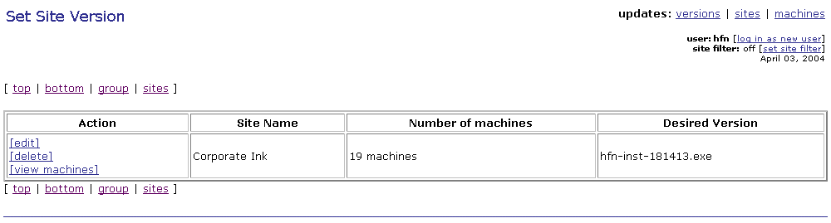
- On the Set Site Version page, click on the [edit] link to the left of the entry for the site where you are updating the ASI client. The Edit a Site Update Record page will be displayed (See figure below).
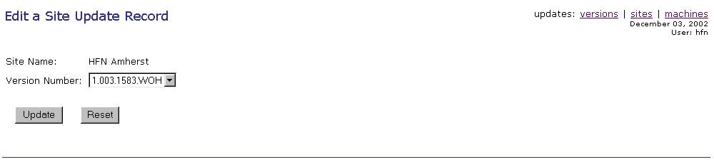
- From the Version Number drop down list, select the version record that you just added and click on the  button. The Site Update Record Updated page shown below will be displayed.
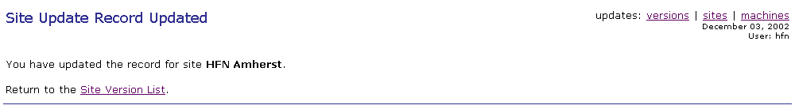
- Click on the Site Version List link. The Set Site Version page will be displayed once again (See figure below). The name of the version you assigned to the site where you are upgrading the ASI client should now be listed in the Desired Version entry for the desired site.

Assigning one version to multiple sites in one step
If you want to assign a version to more than one site with a single operation, you should perform the following steps:
- On the Set Site Version page, click on the group link found among the page navigation links at the top of the Set Site Version page below the page title, and at the bottom of the page. The Group Assign Site Update Record page will be displayed (See figure below).
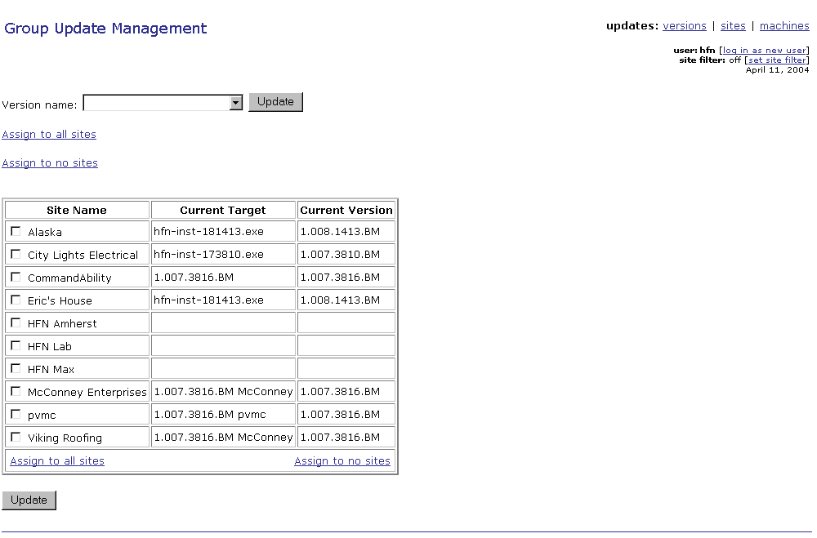
- If you want to assign a version to all sites you have access to, click on the Assign to all sites link at the bottom of the table listing the sites accessible to you.
Otherwise, click on the boxes to the left of the entry for each site that you want to assign the selected version record to.
Please note that all existing version assignments for the sites selected for group assignment are overridden by this action.
- Select the version you want to assign to selected sites as their desired version from the pull down list to the right of the Version name label.
- Click on the button. The Site Update Record Updated page will be displayed (See figure below).

Note on version assignment removal
If you want to remove a version assignment, you should first click on the box to the left of the of the entry for the sites whose version assignment you want to remove (or click on the Assign to all sites link found both above and below the table listing all sites accessible to you), make sure that NO version name is selected in the pull down list to the right of the Version name label, and then click on the button.

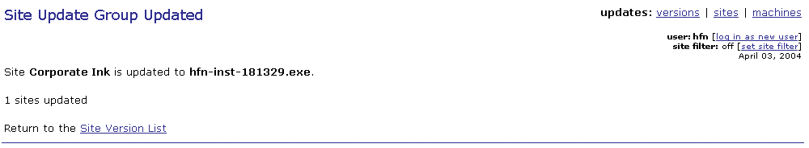

A note about version number comparison and forced updates
Scrip 208 manages ASI client updates on each system where the ASI client is installed. When it contacts the ASI Updates module to see if there is an ASI client to be installed, among other things it gives the ASI Updates module the version number of the ASI client on the system it is reporting from.
If the ASI client version number reported by Scrip 208 is greater (meaning that the ASI client version is newer) than the version number in the version record assigned to the site where the system is located,, Scrip 208 will not proceed with the ASI client update process.
The exception to this rule is represented by forced updates. There are circumstances when you might want to force the installation of an ASI client version regardless of whether it is newer than the one currently installed at a site or not.
You can force the update of the ASI client on individual systems by clicking on the box in the Force? column entry for the system(s) where you want to force the ASI client upgrade on their site’s Machine Update Status page. If you want to force an ASI client upgrade on all systems at a site, just click on the box to the left of the Force All label at the right bottom corner of that site’s Machine Update Status page.
Please make sure that after you enable forced update of the ASI client on selected systems, or an entire site, you click on the  button on the Machine Update Status page, otherwise the forced update selections will not be recorded.

Scheduled execution of remote ASI client update
At this point you are done. The next time Scrip 208 (Software Update) runs on the systems at the site with the assigned desired version, it will find that a version record has been assigned to its site, will download the ASI client installation executable from the download URL specified in the version record, and will install it.
By default, Scrip 208 is scheduled to run at 4 PM and 5 AM every day. After it has run at one of its scheduled times, to check the status of the ASI client update process, click on the [view machines] link to the left of the name of the site you have configured the remote ASI client update for in the Set Site Version page. That site’s Machine Update Status page will be displayed (See figure below). Here you can view all the systems whose ASI client has contacted the ASI server for an update. Please note that even though the ASI client on a system may have successfully contacted the Updates module, as indicated by the entry in the New Version column, it does not mean that the ASI client update has been performed successfully.
In order to find out the actual status of the ASI client update process please perform the steps described in the Checking the status of ASI client update process section of this document.
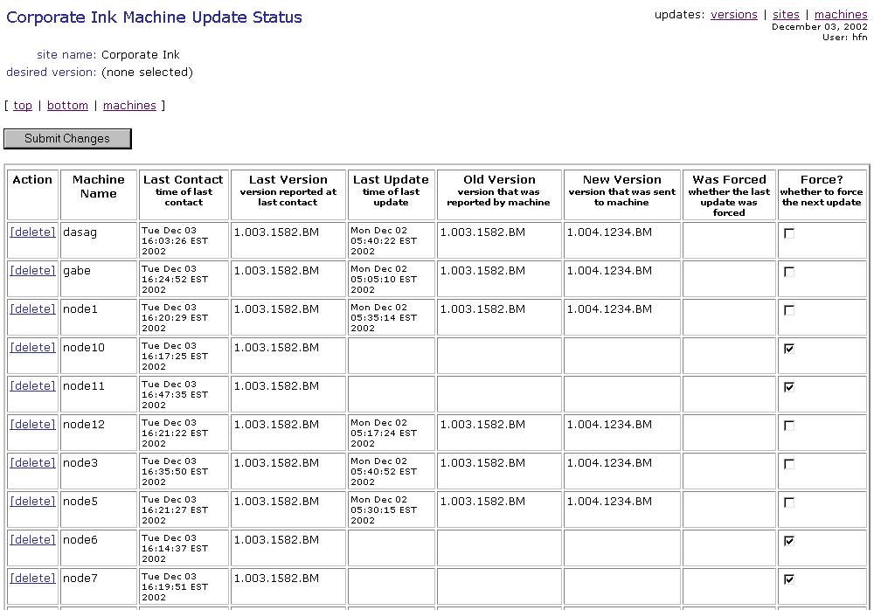

On-demand remote ASI client update execution
After you have created a version record for the site where you want to perform the remote ASI client update, as described in section Setting up a remote ASI client update of this document, if you want to update the ASI client immediately, rather than wait for the next scheduled execution of Scrip 208. please follow the steps below.
- To perform an ASI client update on demand (for example to test how it works), click on the configuration link under the Site Management heading on the Welcome page, or to the right of the sites: label at the upper right-hand corner on any page on the ASI event management facility. The Sites page of the configuration module of the ASI site management facility, shown below, will be displayed.
Once you access a module in the configuration module of the ASI site management facility, a second level navigation bar appears on the page:
- configuration: sites | machines
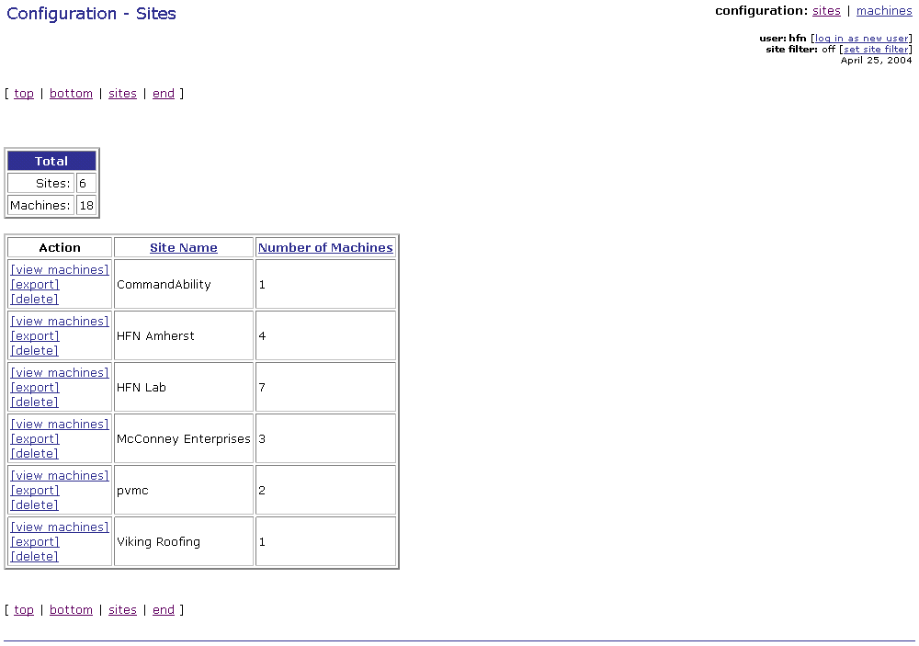
- Click on the [view machines] link to the left of the entry for the site where you want to install the ASI client update. The site’s Machines page will be displayed (See figure below)
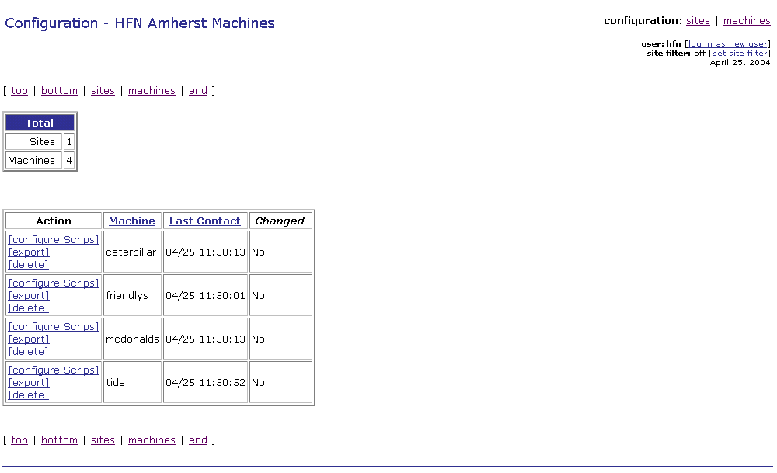
- On the Machines page, click on the [configure Scrips] link for any of the systems listed. That system’s, Scrip Configurator, page will be displayed listing all the Scrips that can be configured on that system in ascending order by Scrip number (See figure below).
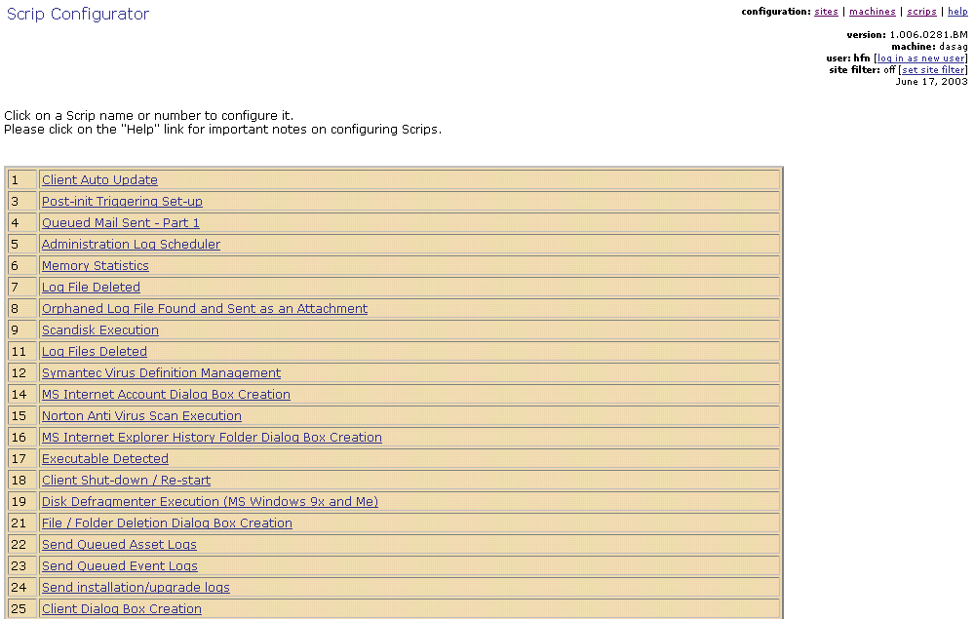

- Scroll down the Scrip Configurator, page until the entry for Scrip 208 is visible and click on it. The Scrip’s configuration page will be displayed (See figure below).
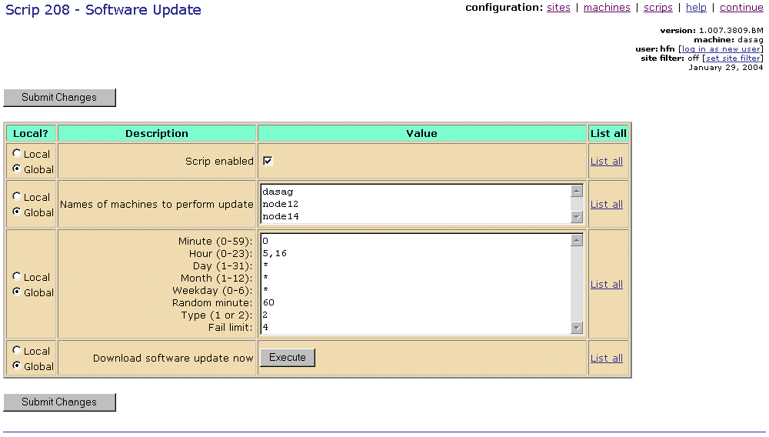

- Click on  the button on the Changes recorded page will be displayed (See figure below).
Please refer to the Scrip 208 configuration help file for detailed information about the Scrip and its configuration. The configuration help file is available online on the ASI server and accessed by clicking on the help link on the configuration navigation bar on the Scrip’s configuration page.
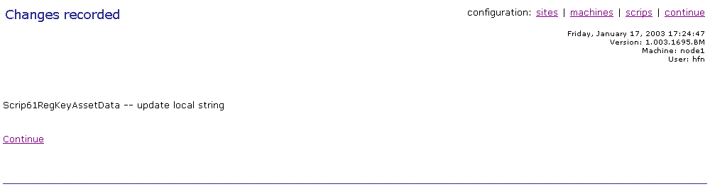
- The next time Scrip 177 (Scrip Configuration Update) from any of the ASI clients at the site contacts the server, it will find the Scrip 208 configuration change (your command to run the ASI client software update on demand). It will download this change, apply it to its system, and propagate it automatically to all systems at the site that are on the same sub-net.
By default, Scrip 177 is schedule to run on each system at a site once per hour with a random minute interval of 50 (i.e. it will run within 50 minutes of its scheduled execution time).

Checking the status of ASI client update process
You can check the progress of the ASI client update process by retrieving the Scrip 208 event logs from the site where you just ran the ASI client update. To do this you need to access the Ad-hoc Event Query Form page and retrieve Scrip 208’s event logs performing the following steps:
- Click on the ad-hoc query link under the Event Management heading on the Welcome page, or to the right of the events: label at the upper right-hand corner on any page on the ASI management server. The Ad-hoc Event Query Form page will be displayed (See figure below).
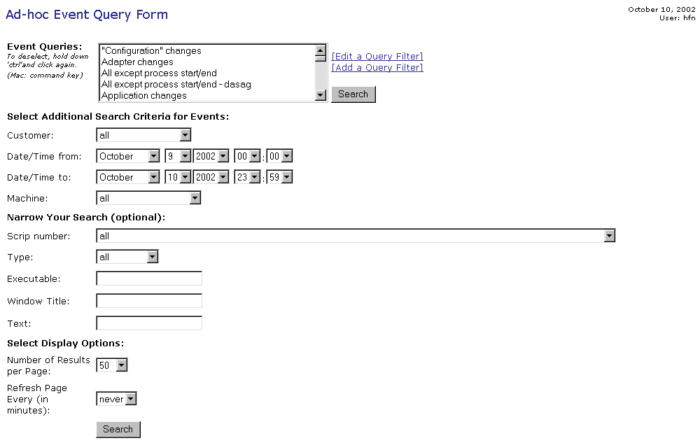
- On the Ad-hoc Event Query Form page, from the Customer pull down list select the name of the site where you ran Scrip 208 to perform the ASI client update.
- From the Scrip number pull down list, click on the entry for Scrip 208.
- Assuming that you are running the event query on the same day you performed the ASI client update, you do not need to change the Date/Time from: and Date/Time to: values, or enter/select a value for any of the other query parameters.
- Click on the  button. The Query Results page will be displayed (See figure below).
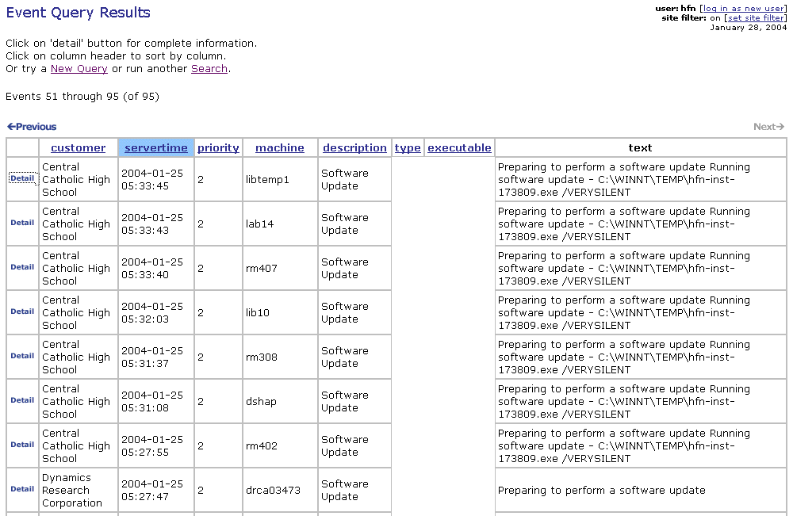
- Clicking on the Detail button will take you to the Event Detail page of a Scrip 208 event log (See figure below).
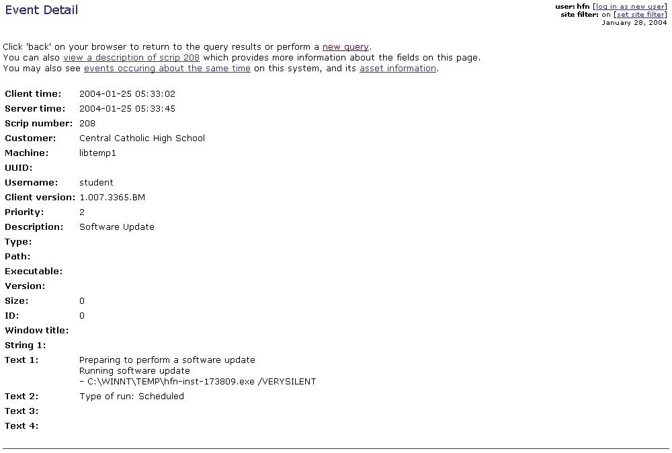
The content of each entry in the Event Detail page varies depending on the Scrip that was triggered by the event. Please refer to the Event Detail page help files for a description of each Scrip’s detail page. You can access them directly from Event Detail page by clicking on the view a description hyperlink.
Clicking on the events occurring about the same time link will take you to a page that lists the events that took place on the system in question within an interval of +/- ten minutes.
Clicking on the asset information link will take you the Asset Detail page of the system whose ASI client reported the event.
Please refer to the Automated Support Infrastructure Event Management User Guide for detailed information on the ASI event management facility.

